Functional Design Document

Download Selected Workflow Item(s) from Workflow App List

Table of Contents

Download Selected Workflow Items from Workflow App List 2

Current Challenge: 2

User Story 1: Download option in Workflow App List’s toolbar 3

Mock Up: 3

Conditions: 3

# Download Selected Workflow Items from Workflow App List

As a workflow user, I may need the ability to download certain Workflow Items from the Workflow App List.

### Current Challenge:

The user has no way download the Workflow Items from the Workflow App List.

# User Story 1: Download option in Workflow App List’s toolbar

Download option will be available within the Workflow App List’s toolbar, refer to below mock up.

### Mock Up:

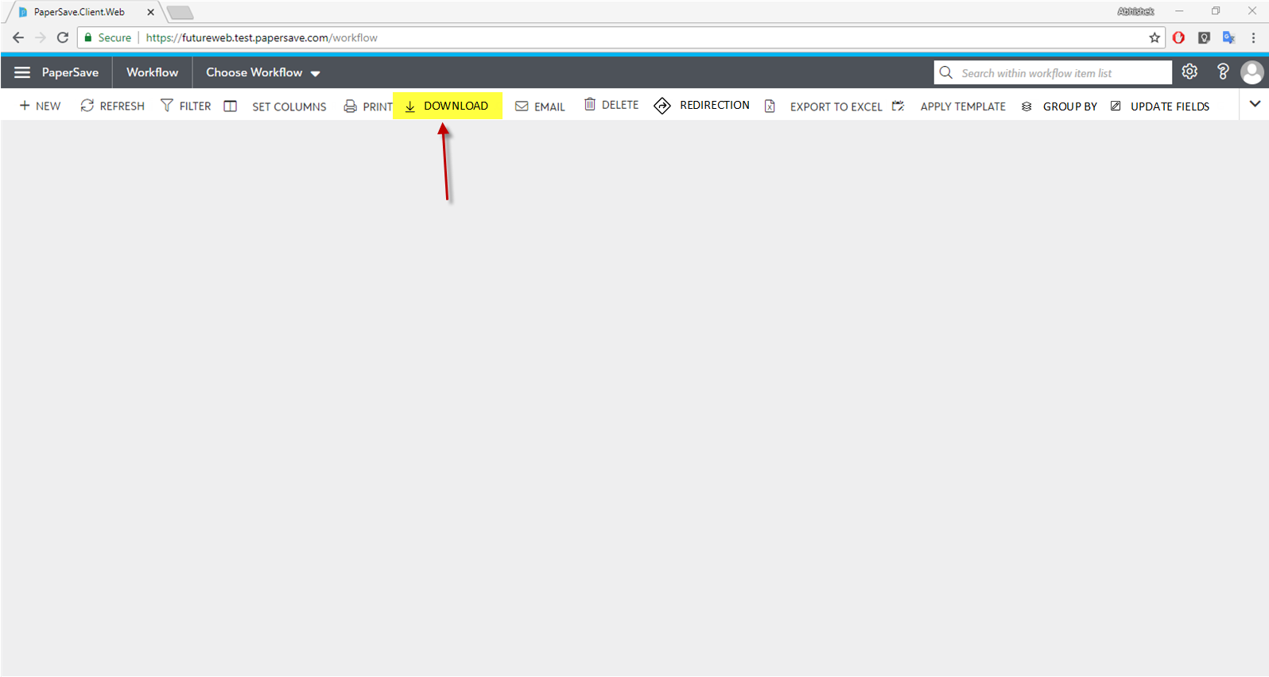

### Conditions:

#### Condition 1: Enabling Download button

* Download button will get enable if the below condition is met:
  + If at least one or more workflow items are selected.

#### Condition 2: Delete mechanism

* ~~Once the user has selected one or more workflow item(s) in the list, and upon clicking on “Download” button, it will then start downloading the selected items to the default download directory set for the current browser.~~
* Once the user has selected only a single workflow item, then upon clicking on the “Download” button, it should then initiate a browser download operation as mentioned below:
  + The downloaded file should have the below naming convention:
    - *WORKFLOWITEMID + CURRENT DATE AND TIME*
* Once the user has selected multiple workflow items, then upon clicking on the “Download” button, it should then initiate a browser download operation as mentioned below:
  + It should generate a zip file containing all the selected workflow items with the name of the zip file as:
    - *“Workflow items of “ + WORKFLOWNAME + “ workflow - “ + CURRENT DATE AND TIME*
  + Each workflow item’s name within the zip file should have the below naming convention:
    - *WORKFLOWITEMID + “ - “ + CURRENT DATE AND TIME*
* Upon successful or unsuccessful completion of the Delete operation:
  + It should deselect the selected workflow items.

#### Acceptance Criteria 1: Verifying Conditions

Verify all the conditions mentioned above. (Condition 1 to 2)